**HTML Quotations & Citations**

**HTML Quotations & Citation Tags:**

There are some **Quotations** and **Citation** tags that we learn in this chapter:

1. <blockquote>
2. <q>
3. <abbr>
4. <address>
5. <cite>
6. <bdo>

**Example:**



**HTML <blockquote> for Quotations:**

The HTML <blockquote> element defines a section that is quoted from another source.

Browsers usually indent <blockquote> elements.

**Code:**

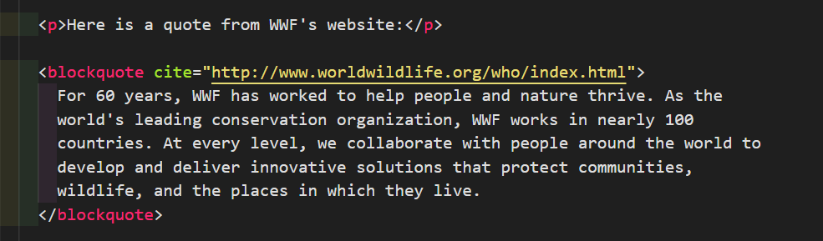

**Output:**

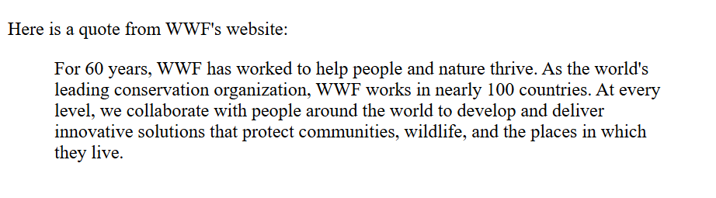

**HTML <q> for Short Quotations:**

The HTML <q> tag defines a short quotation.

Browsers normally insert quotation marks around the quotation.

**Code:**

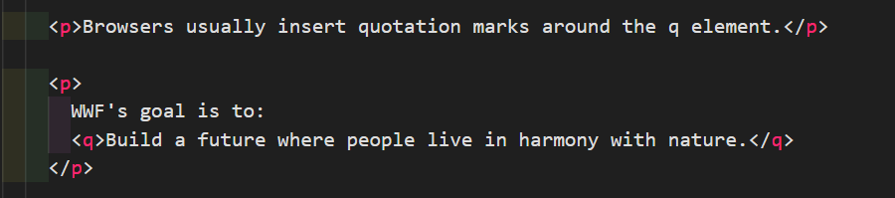

**Output:**

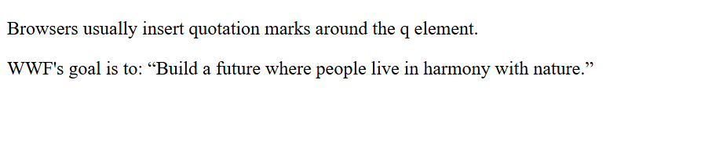

**HTML <abbr> for Abbreviations:**

The HTML <abbr> tag defines an abbreviation or an acronym, like "HTML", "CSS", "Mr.", "Dr.", "ASAP", "ATM".

Marking abbreviations can give useful information to browsers, translation systems and search-engines.

Tip: Use the global title attribute to show the description for the abbreviation/acronym when you mouse over the element.

**Code:**

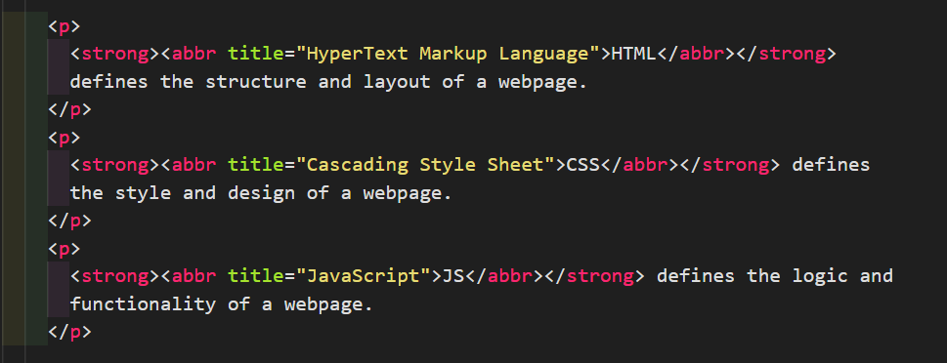

**Output:**

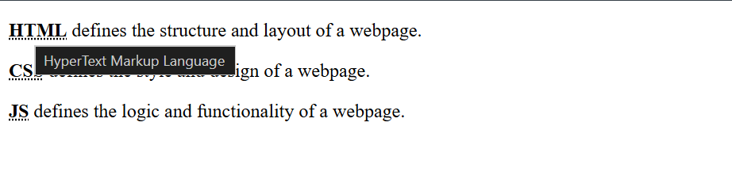

**HTML <address> for Contact Information:**

The HTML <address> tag defines the contact information for the author/owner of a document or an article.

The contact information can be an email address, URL, physical address, phone number, social media handle, etc.

The text in the <address> element usually renders in italic, and browsers will always add a line break before and after the <address> element.

**Code:**

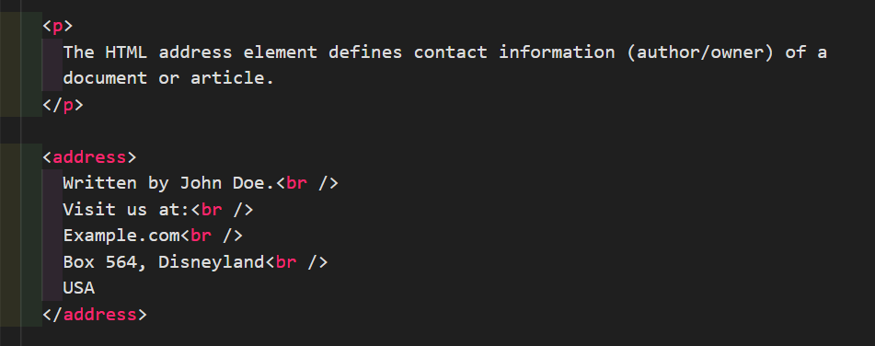

**Output:**

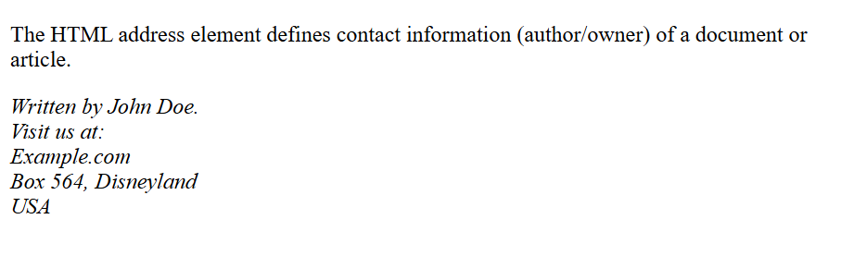

**HTML <cite> for Work Title:**

The HTML <cite> tag defines the title of a creative work (e.g. a book, a poem, a song, a movie, a painting, a sculpture, etc.).

Note: A person's name is not the title of a work.

The text in the <cite> element usually renders in italic.

**Code:**

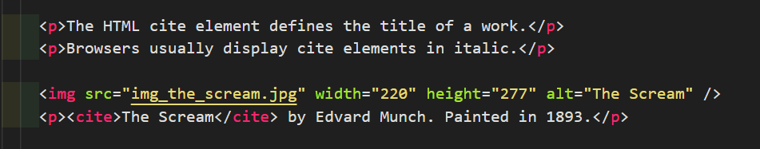

**Output:**

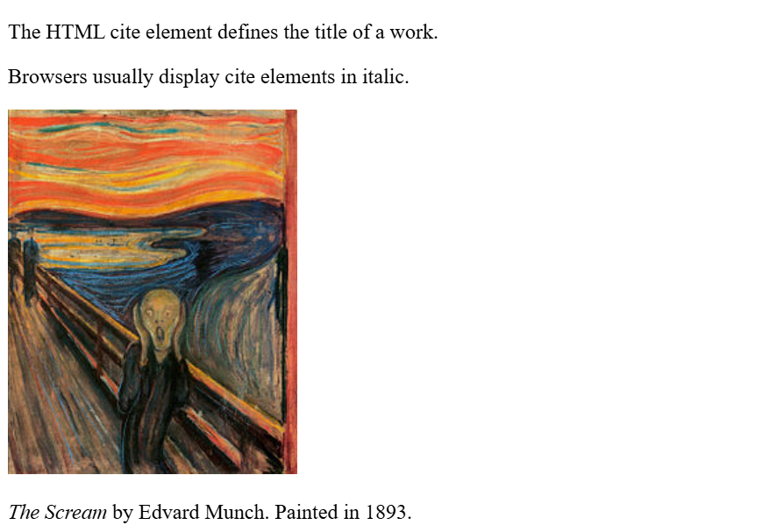

**HTML <bdo> for Bi-Directional Override:**

BDO stands for Bi-Directional Override.

The HTML <bdo> tag is used to override the current text direction:

**Code:**



**Output:**

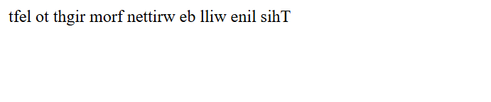

**Summary:**

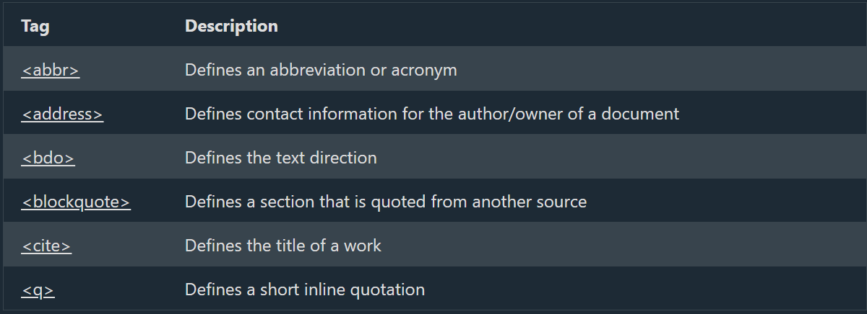

**Reference:**

<https://www.w3schools.com/tags/tag_abbr.asp>

<https://www.w3schools.com/tags/tag_address.asp>

<https://www.w3schools.com/tags/tag_bdo.asp>

<https://www.w3schools.com/tags/tag_blockquote.asp>

<https://www.w3schools.com/tags/tag_cite.asp>

<https://www.w3schools.com/tags/tag_q.asp>